**1. Start Capturing Packets**

* Open Wireshark.
* Select the **active network interface** (usually Wi-Fi or Ethernet).
* Click the **blue shark fin icon** to start the live capture.

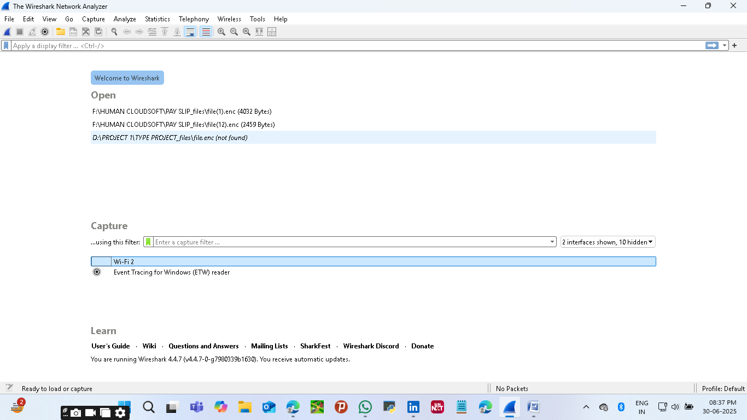

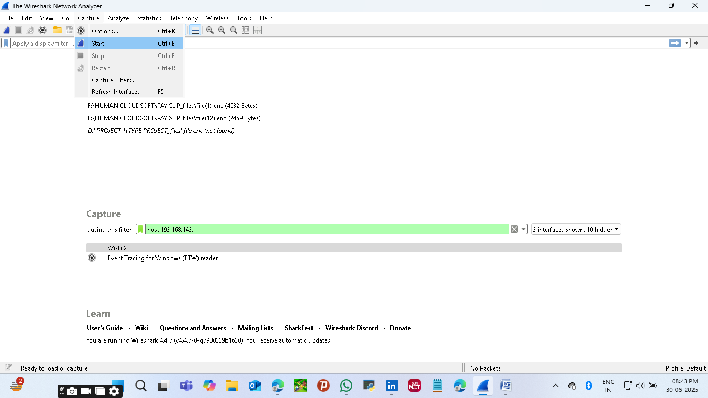

#### 2. ****Generate Traffic****

* While Wireshark is capturing:
  + - Open a browser and visit websites like example.com or wikipedia.org.
    - This will create visible packet traffic.

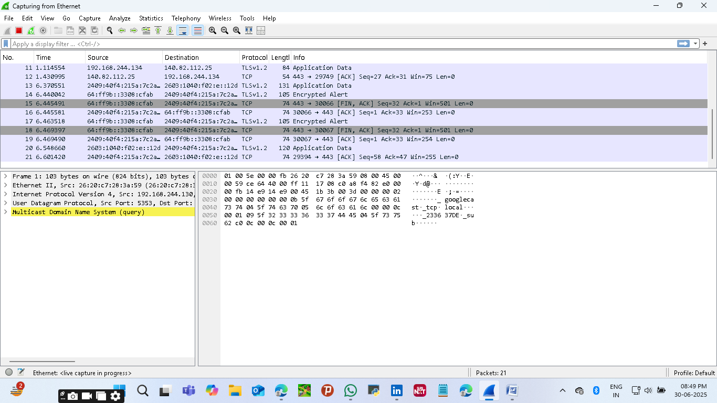

#### 

#### 4. ****Stop the Capture****

* After about one minute, click the **red square icon** to stop the capture.

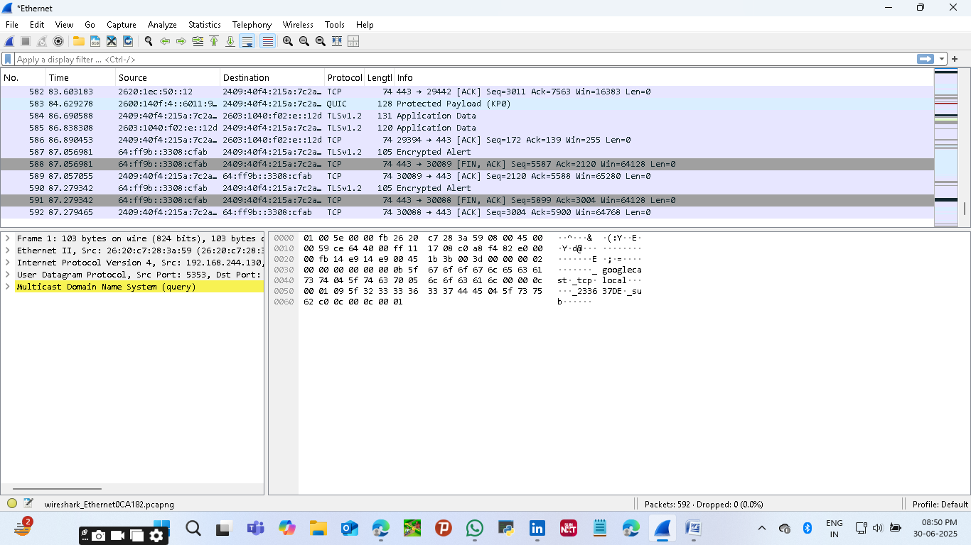

#### 5. ****Filter by Protocol****

Use the **Display Filter** bar to view specific protocol packets:

* For DNS: dns
* For HTTP: http
* For TCP: tcp (Use one at a time)

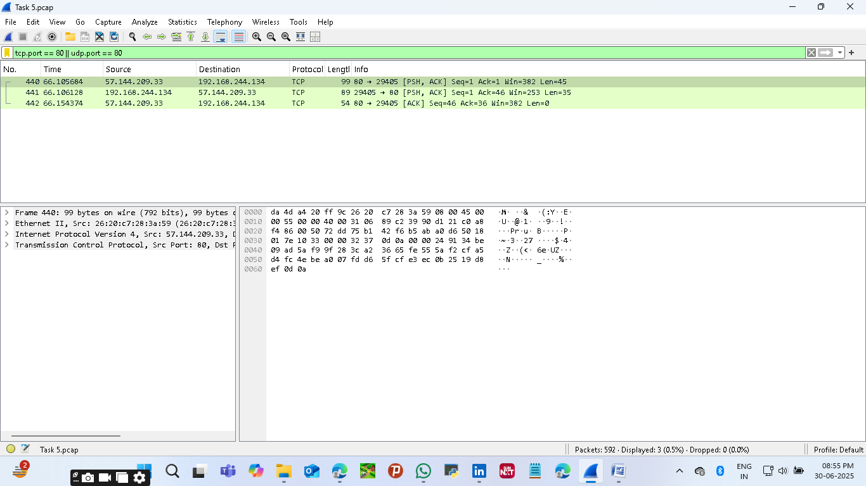

#### 6. ****Identify at Least 3 Protocols****

* Look through the Protocol column. Some common ones you'll likely see:
  + DNS – Domain Name System
  + TCP – Transmission Control Protocol
  + HTTP or HTTPS – Web traffic
  + ICMP – For ping responses

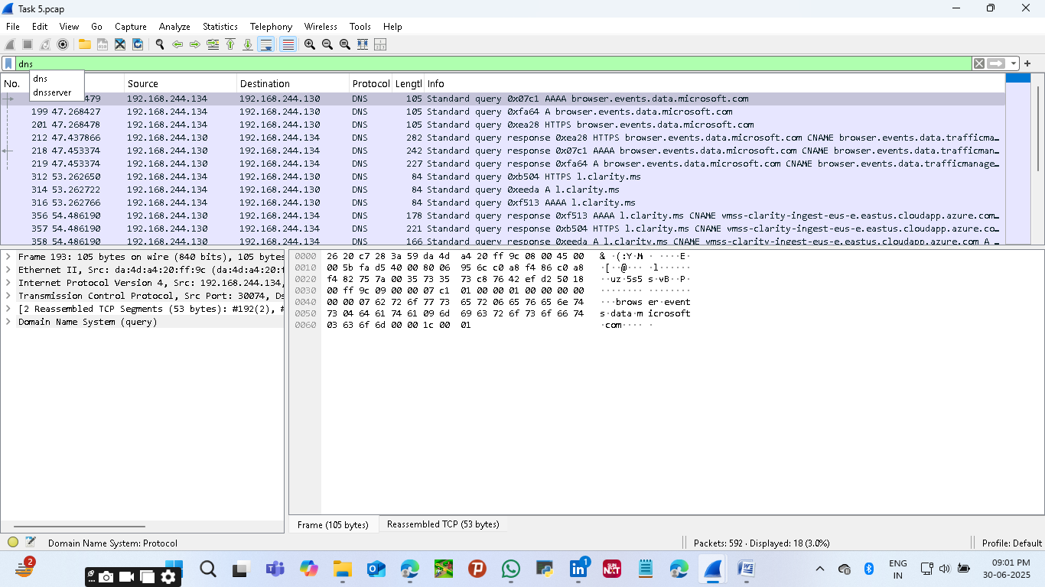

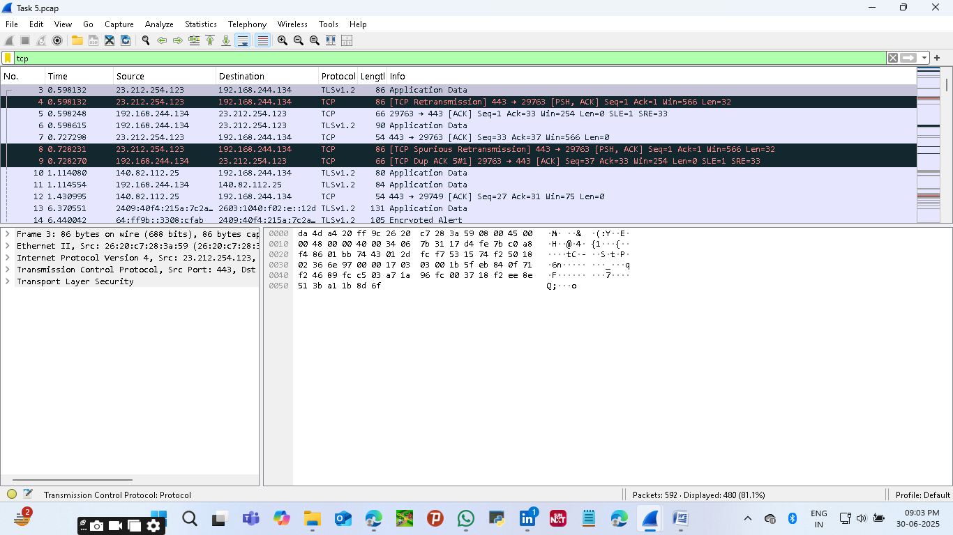

#### 7. ****Export as .pcap File****

* Click **File → Save As**.
* Choose a location and save with a .pcap extension.

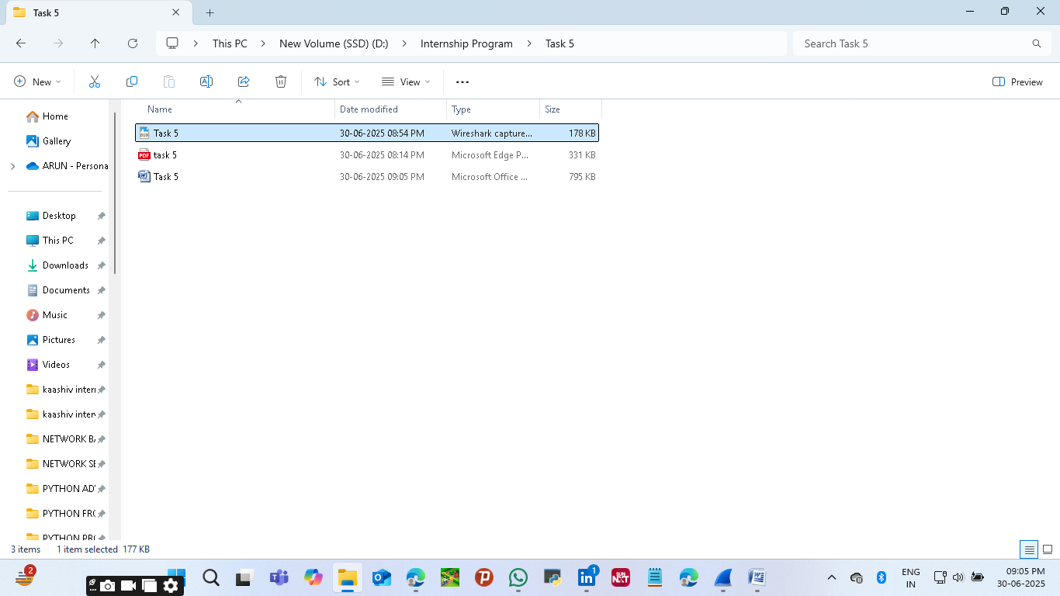

### ****Network Traffic Analysis Summary****

**Protocols Identified:**

1. **DNS (Domain Name System)**
   * Used to resolve domain names like google.com into IP addresses.
   * Example: A DNS query and response for wikipedia.org.
2. **HTTP (HyperText Transfer Protocol)**
   * Detected during web page requests over unencrypted channels.
   * Example: GET /index.html request to example.com.
3. **TCP (Transmission Control Protocol)**
   * Facilitates reliable communication between devices.
   * Example: Typical 3-way handshake—SYN, SYN-ACK, ACK.

**Conclusion:** The capture reveals standard user-generated traffic. DNS queries show the name resolution process. HTTP traffic reflects typical web browsing. TCP handshakes confirm session establishment. Together, they offer insight into how layers of the OSI model coordinate for even simple actions like visiting a website.